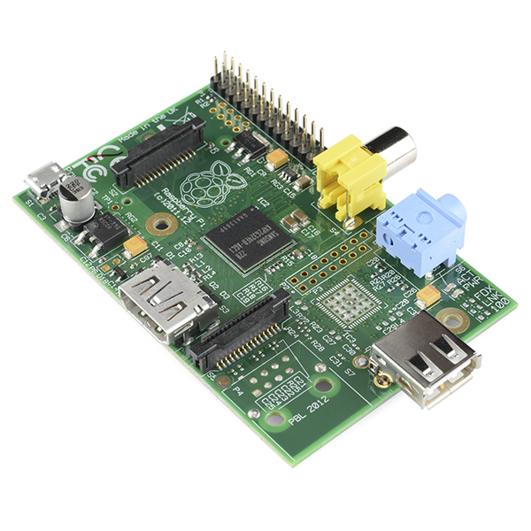
Raspberry pi Model B

Technical specifications

1.Broadcom BCM2835 ARMv6Z (32-bit)

